|  |  |  |  |
| --- | --- | --- | --- |
| logo | Check Point Threat Extraction Secured This Document | get_orig_image | [Get Original](http://gw.forbes.nsw.gov.au/UserCheck/PortalMain?IID=%7b64534D5E-45E8-62BE-5384-8C00D1DC1B66%7d&origUrl=) |

Reymond Street Planning Proposal

Forbes Shire council

2023

Table of Contents

[INTRODUCTION 2](#_Toc128751519)

[Background 2](#_Toc128751520)

[THE PROPOSAL 3](#_Toc128751521)

[Objectives and intended outcomes 3](#_Toc128751522)

[Explanation of provisions 3](#_Toc128751523)

[Justification 3](#_Toc128751524)

[The need for the planning proposal 3](#_Toc128751525)

[Relationship to the strategic planning framework 3](#_Toc128751526)

[Environmental, Social and Economic Impact 6](#_Toc128751527)

[Mapping 7](#_Toc128751528)

[Community Consultation 7](#_Toc128751529)

[Project Timeline 7](#_Toc128751530)

[Appendix A –Site photos 8](#_Toc128751531)

INTRODUCTION

Background

The Reymond Street Forestry Area (Lot 1618 DP 750158) is a portion of land owned by Council that has three separate uses.

The northern portion of the site is a Community Garden operated independently by the *Forbes Community Garden Committee.*

The site was historically owned by Forbes State Forest (now Forestry Corporation). In 1952 an Amenity Nursery was built by Forbes State Forest and it holds an arboretum of about 150 species (often referred to as the Forbes Urban Forest). In the mid-1950s to early 1960s, a shed was constructed as a maintenance depot for Forbes State Forest and a manager's residence on the eastern portion of the site. Both are still on the site and under use today, though the dwelling is rented privately by Council.

The property was sold to Council in 2018 with a lease in place with Forestry Corporation NSW for the continued use of the sheds at the rear of the property.

The Community Gardens (which is the original nursery area from the Forestry Days) is leased to the Forbes Riverside Community Gardens Inc.

The entire site is currently zoned RU3 Forestry. This Planning Proposal proposes to rezone the majority of the site to RE1 Public Recreation. The intent is to allow the northern portion to continue being a community garden (defined in the LEP as a *Community Facility),* and the southern portion to become a public “urban forest”. It is intended that the southern portion of the site will be a passive public recreation area for residents of the Shire, and all flora will be preserved. Forestry NSW will continue their use of the depot under provisions of the *State Environmental Planning Policy (Transport and Infrastructure) 2021,* as maintenance depots by a public authority are *permitted without consent* on operational land (Clause 2.67). The dwelling house site is proposed to be rezoned to R1 General Residential.

The site is operational land in accordance with the *Local Government Act 1993.* It is not proposed to be reclassified. Refer Schedule 1 of the proposal for photos of the site.

THE PROPOSAL

Objectives and intended outcomes

The objective of the proposal is to rezone land currently zoned as RU3 Forestry to reflect the current and ongoing uses of the site. This will provide a more logical zoning while preserving the existing community uses and maintaining the urban forest.

There is a potential for Council to subdivide off the portion of the site that contains a dwelling house. While the site can be further subdivided (ie Battle Axe or otherwise), this would be unlikely due to the constraints associated with achieving access from a Classified Road and associated development costs.

Explanation of provisions

The proposal will be achieved by amending the mapping of the *Forbes Local Environmental Plan 2013* to reflect the zones as detailed below.

|  |  |  |  |
| --- | --- | --- | --- |
| **Development Control** | **Current** | **Proposed (western)** | **Proposed for dwelling site** |
| Zoning | RU3 Forestry | RE1 Public Recreation | R1 General Residential |
| Minimum Lot Size | Nil | Nil | 550sqm |
| Height of Buildings | Nil | 10m | 8.5m |

Justification

The need for the planning proposal

*Is the planning proposal a result of an endorsed LSPS, strategic study or report?*

No. The planning proposal is not the result of a strategy as it is proposing to rezone the land to reflect the current and ongoing uses of the site. As the land is no longer owned and managed by Forest Corporation NSW, it is appropriate to rezone the land from RU3 Forestry to RE1 Public Recreation and R1 General Residential.

*Is the planning proposal the best means of achieving the objectives or intended outcomes, or is there a better way?*

Yes. This is the only mechanism to rezone the property.

Council considered whether C3 – Environmental Management would be a more appropriate zone compared to RE1 Public Recreation.

The objectives of C3 Environmental Management state that the zone should "provide for a limited range of development that does not have an adverse effect on [ecological, scientific, cultural or aesthetic values]”. Several development types are permissible in the C3 zone such as dwelling houses, animal boarding establishments and bed and breakfast accommodation which would ultimately render the site unusable for its current uses due to the limited capacity.

Conversely, the objectives of the RE1 Public Recreation zone focuses on the ability for the land to be used for recreation and public open space, as well as to protect and enhance the natural environment for recreational purposes. As the two uses proposed (community facility (community garden) and public open space are both permissible in this zone, and the objectives prioritise the environment and public open space over development, Council believes it is a far more appropriate zone. Both land uses are Public Recreation uses and this zone will result in a better protection of the environment as the dwelling houses are not permissible.

Relationship to the strategic planning framework

*Will the planning proposal give effect to the objectives and actions of the applicable regional or district plan or strategy?*

No, as the proposal has been instigated by a change of ownership of the land. As the land is no longer owned and managed by Forest Corporation NSW, it is appropriate to rezone the land from RU3 Forestry to zones which meet the existing and ongoing uses of the site.

*Is the planning proposal consistent with a council LSPS that has been endorsed by the Planning Strategy or GSC, or another endorsed local strategy or strategic plan?*

Yes, the proposal is consistent as it continues to preserve areas of significant biodiversity and community facilities. While this proposal is not specifically proposed in the LSPS, the Strategy does recommend that Council “improve community facilities to support a diverse lifestyle”. As this proposal opts to maintain community facilities, it is generally consistent with Councils LSPS.

*Is the planning proposal consistent with any other applicable state and regional studies or strategies?*

No other applicable state or regional studies or strategies apply to the proposal.

*Is the planning proposal consistent with applicable State Environmental Planning Policies?*

|  |  |  |
| --- | --- | --- |
| **State Environmental Planning Policy** | **Consistency** | **Comment** |
| Primary Production 2021 | Yes | The proposal seeks to rezone land that is technically currently zoned rural (RU3 Forestry). However, this SEPP does not provide any matters for consideration and therefore the proposal is generally consistent. |
| Resources and Energy 2021 | NA |  |
| Resilience and Hazards 2021 | Yes | The land is flood liable. As the proposal does not propose any change of land uses it generally complies with this SEPP.  There is a small risk of pesticides being associated with the depot of Forestry Corporation NSW. As the proposal does not propose a change of use from its current operation, this is considered low risk. Should any change of use be proposed, contamination risk would be managed through the development assessment process in accordance with the Resilience and Hazards SEPP |
| Industry and Employment 2021 | NA |  |
| Transport and Infrastructure 2021 | Yes | The SEPP provides a number of uses that are permitted without consent on parks and other public reserves (Division 12) and operational land (Division 10A). The proposal does not involve any works and will not change the ability to make use of these clauses. |
| Biodiversity and Conservation 2021 | Yes | There is significant planted vegetation on the site as planted by Forestry NSW in the middle of the 20th century. This is proposed to be preserved as a public recreation space. |
| Planning Systems 2021 | NA |  |
| Housing 2021 | NA |  |
| Exempt and Complying Development Codes 2008 | NA |  |

*Is the planning proposal consistent with applicable Local Planning Directions?*

|  |  |  |
| --- | --- | --- |
| **Local Planning Direction** | **Consistency** | **Comment** |
| Implementation of Regional Plans | Yes | The proposal is not inconsistent with the regional plan. |
| Development of Aboriginal Land Council Land | NA |  |
| Approval and Referral Requirements | Yes | Nothing in this plan requires the concurrence of a public authority, nor does it identify designated development. The site has frontage to a State Road, though it is not proposed to create a new access as the land uses are not changing. |
| Site specific provisions | NA | The planning proposal does not propose to make a specific use permissible. |
| Focus area 1 – Planning Systems – Place-based | NA | The planning proposal is not relevant to any of the areas subject to these directions. |
| Conservation Zones | NA | The planning proposal does not apply to a conservation zone, or land otherwise identified for environmental conservation or protection. There is significant biodiversity on the site, and Council proposes to retain this for public recreation. |
| Heritage Conservation | NA | There are no heritage items on the land subject to this proposal. |
| Sydney Drinking Water Catchment | NA |  |
| Application of C2 and C3 Zones and Environmental Overlays in Far North Coast LEPs | NA |  |
| Recreation Vehicle Areas | NA |  |
| Strategic Conservation Planning | Yes | There is significant biodiversity on the site, and Council proposes to retain this for public recreation. |
| Flooding | Yes | The site is flood liable, being low hazard flood fringe in its entirety. As the proposal is not increasing density of the site, and the site is low hazard, the proposal complies with this direction.  Subclause (2) of this direction states that a Planning Proposal must not rezone land from rural to a residential use. This is applicable for the existing dwelling house portion of the site. As the rezoning is not increasing density from the current use, and it rather allowing the zoning to reflect how the site is currently used, it is thought to be a reasonable inconsistency with the objective to accept. |
| Coastal management | NA |  |
| Planning for bushfire protection | NA |  |
| Remediation of Contaminated Land | Yes | There is a small risk of pesticides being associated with the depot of Forestry Corporation NSW. As the proposal does not propose a change of use from its current operation, this is considered low risk. Should any change of use be proposed, contamination risk would be managed through the development assessment process in accordance with the Resilience and Hazards SEPP. |
| Acid sulfate soils | NA |  |
| Mine Subsidence and Unstable Land | NA |  |
| Integrated Land Use and Transport | NA |  |
| Reserving Land for Public Purposes | Yes | The land is not community land, and therefore this direction does not apply. |
| Development Near Regulated Airports and Defence Fields | NA |  |
| Shooting Ranges | NA |  |
| Residential Zones | Yes | The proposal introduces new residential land. However, this constitutes one block at 1500sqm and has adequate services, including water, sewer and electricity. |
| Caravan Parks and Manufactured Home Estates | NA |  |
| Focus Area 7: Industry and Employment | NA |  |
| Focus Area 8: Resources and Energy | NA |  |
| Rural Zones | Yes, with justification | The proposal proposes to rezone 1500sqm of rural land (RU3 Forestry) to residential land. This land is in town and has all appropriate services, and is not used for an agricultural purpose. It is therefore considered unreasonable to require compliance with this direction. |
| Rural Lands | Yes, with justification | The proposal seeks to rezone land that is technically currently zoned rural (RU3 Forestry). However, the land is no longer owned by Forestry Corporation and is not used for agricultural purposes, except the storage of vehicles associated with the maintenance depot. This use will be retained. As the site is being rezoned to RE1 Public Recreation, it will be a far more logical use of the size than preserving its RU3 status. The site is less than 2 hectares and within the urban area of Forbes, and is therefore not suitable for any agricultural use. It is not reasonable to require compliance with this direction. |

Environmental, Social and Economic Impact

*Is there any likelihood that critical habitat or threatened species, populations or ecological communities, or their habitat will be adversely affected?*

No. The land has habitat associated with the urban forest that, while not designated as a critical habitat, is of general importance and Council proposes to retain the urban forest.

*Are there any other likely environmental effects of the planning proposal and how are they proposed to be managed?*

The site is flood liable, being low hazard flood fringe in its entirety. As the proposal is not increasing density of the site or changing the existing uses it is not considered that the proposal will have an unreasonable impact on flooding. Any future development will continue to be managed via the controls of Councils Development Control Plan.

There are no other likely environmental effects anticipated as part of the planning proposal as it is not proposed to change the use of any of the land.

*Has the planning proposal adequately addressed any social and economic effects?*

An AHIMS search has been conducted, and no Aboriginal heritage items have been identified on any of the land subject to the planning proposal. No development is proposed, and therefore the proposal does not meet the thresholds for a due diligence assessment.

No biodiversity is proposed to be removed, and therefore the *Biodiversity Conservation Act 2017* does not apply to the proposal.

There is significant community benefit in retaining the Community Garden and the Urban Forest for generations to come, and therefore it is most appropriate that this area is zoned RE1 Public Recreation so that it remains in the hands of Council.

*Is there adequate public infrastructure for the planning proposal?*

Yes. The site is connected to water, sewer and electricity.

Mapping

Yes, the land use zone maps are required to be changed to reflect the proposal. Council will engage Department of Planning and Environment to make this change.

Community Consultation

Council has spoken to the Riverside Community Garden Inc who support retention of the Community Garden and Urban Forest.

It is anticipated that the proposal will be publicly exhibited for a period of 28 days.

Project Timeline

|  |  |
| --- | --- |
| **Consideration by Council & Council Decision** | April 2023 |
| **Gateway Determination** | June 2023 |
| **Public Exhibition** | July – August 2023 |
| **Public Hearing** | NA |
| **Consideration of submissions** | August 2023 |
| **Post-exhibition review by Council** | September 2023 |
| **Finalisation** | September 2023 |
| **Gazettal of LEP amendment** | September 2023 |

Appendix A –Site photos

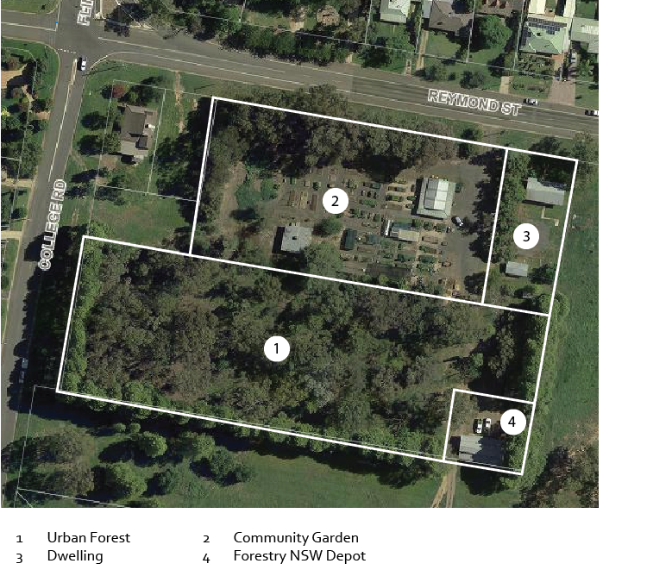  
*Site layout*

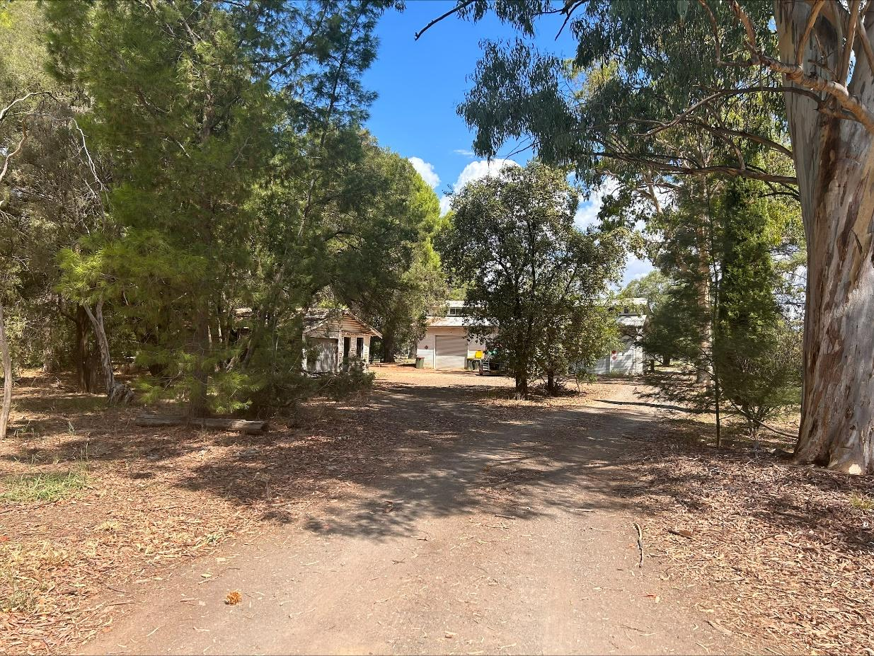

*Forestry Area*

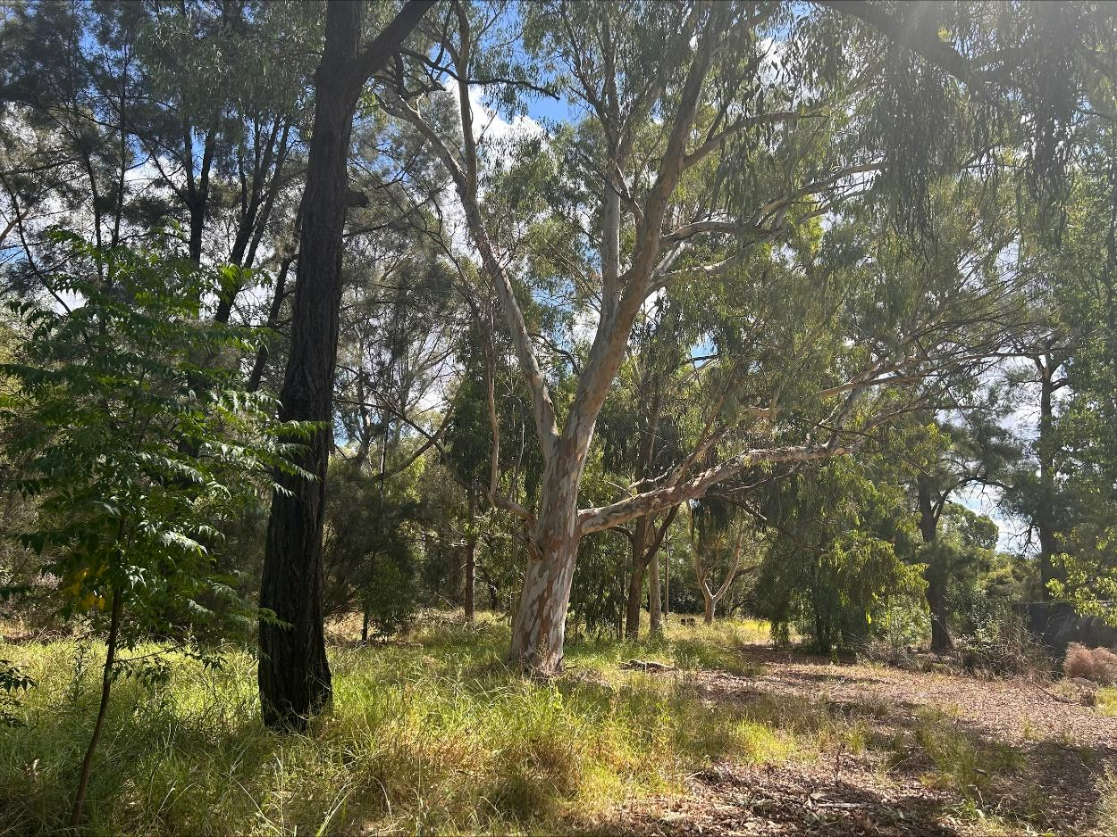

*Arboretum*

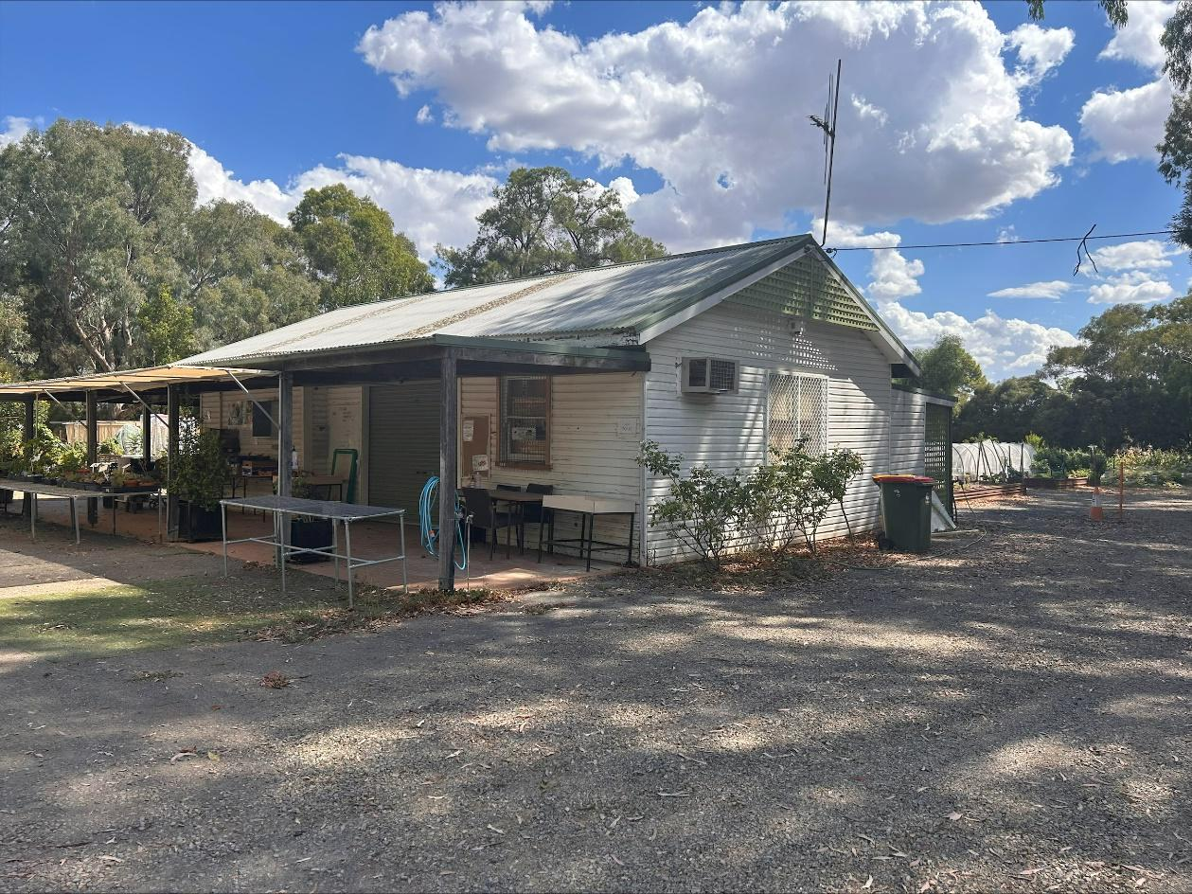

*Community Garden Facilities*

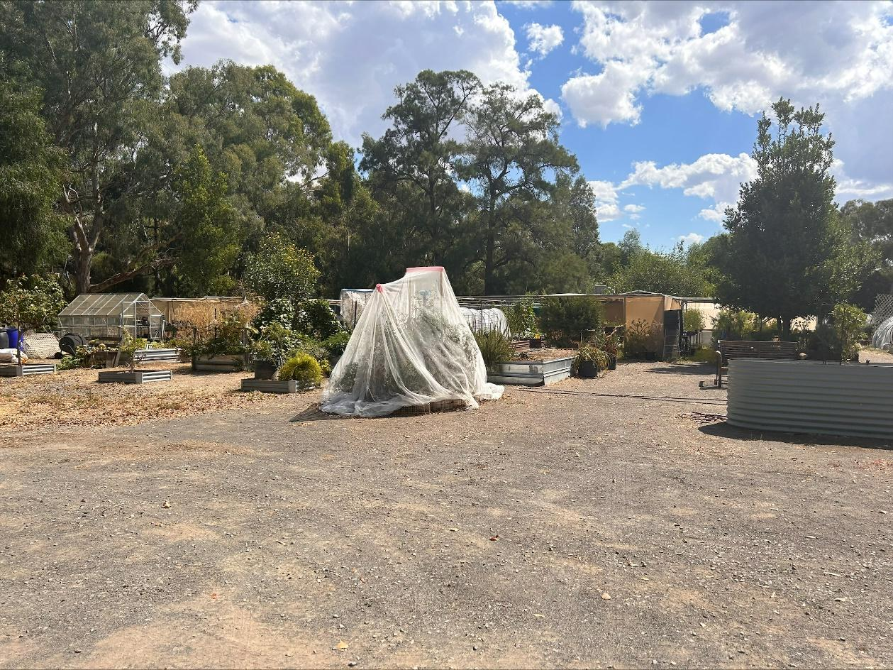

*Community Garden*

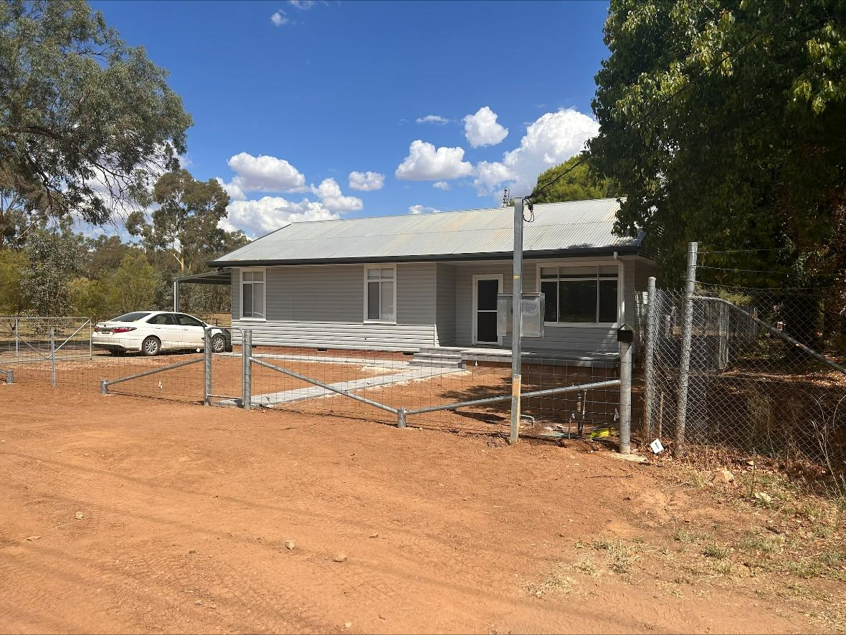

*Dwelling House*

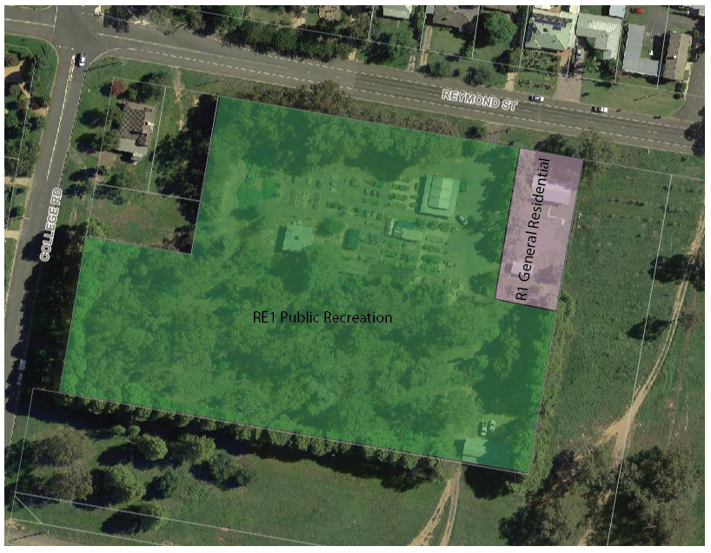

*Proposed Zone Layout*

